ST. XAVIER’S COLLEGE

**(Affiliated to Tribhuvan University)**

**Maitighar, Kathmandu**



**Digital Logic Lab Assignment #16**

10.1. To verify the operation of 1 x 4 DEMUX.

10.2. To verify the operation of 1 x 8 DEMUX.

10.3. To verify the operation of 1 x 16 DEMUX using 4 x 1.

**SUBMITTED BY:**

Gaurav Chaulagain

(017BSCIT014)

**SUBMITTED TO:**

|  |  |
| --- | --- |
| **Er. Saugat Sigdel**  **Lecturer** |  |
| **Department of Computer Science** | |

**DEMULTIPLEXER:**

* A demultiplexer reverses the multiplexing function taking digital information from one line and distributes it to a given number of output lines. It is also known a data distributer which receives information on a single line and transmits its information on one of the 2n possible output lines. The selection of a specific output line is controlled by the bit value of selection lines.

**OBJECTIVE 10.1:**

**TO VERIFY THE OPERATION OF 1×4 DEMUX**

**THEORY:**

* It has 1 input and 4 outputs, where one output is high at a time.
* The Block diagram is given below:

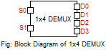

**TRUTH TABLE:**

|  |  |  |  |  |  |
| --- | --- | --- | --- | --- | --- |
| **Switch** | | **Outputs** | | | |
| **S0** | **S1** | **D0** | **D1** | **D2** | **D3** |
| 0 | 0 | 1 | 0 | 0 | 0 |
| 0 | 1 | 0 | 1 | 0 | 0 |
| 1 | 0 | 0 | 0 | 1 | 0 |
| 1 | 1 | 0 | 0 | 0 | 1 |

**CIRCUIT DIAGRAM:**

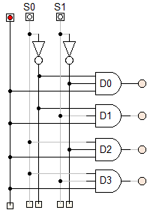

**OBSERVATION:**

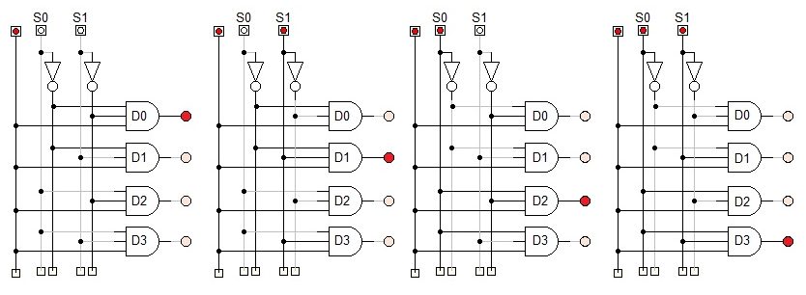

**OBSERVATION TABLE:**

|  |  |  |  |  |  |
| --- | --- | --- | --- | --- | --- |
| **Switch** | | **Outputs** | | | |
| **S0** | **S1** | **D0** | **D1** | **D2** | **D3** |
| 0 | 0 | 1 | 0 | 0 | 0 |
| 0 | 1 | 0 | 1 | 0 | 0 |
| 1 | 0 | 0 | 0 | 1 | 0 |
| 1 | 1 | 0 | 0 | 0 | 1 |

**CONCLUSION:**

Hence, the operation of 1×4 DEMUX was verified.

**OBJECTIVE 10.2:**

**TO VERIFY THE OPERATION OF 1×8 DEMUX**

**THEORY:**

* It has 1 input and 8 outputs, where one output is high at a time.
* The Block diagram is given below:

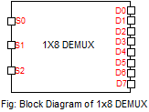

**TRUTH TABLE:**

|  |  |  |  |  |  |  |  |  |  |  |
| --- | --- | --- | --- | --- | --- | --- | --- | --- | --- | --- |
| **Switch** | | | **Outputs** | | | | | | | |
| **S0** | **S1** | **S2** | **D0** | **D1** | **D2** | **D3** | **D4** | **D5** | **D6** | **D7** |
| 0 | 0 | 0 | 1 | 0 | 0 | 0 | 0 | 0 | 0 | 0 |
| 0 | 0 | 1 | 0 | 1 | 0 | 0 | 0 | 0 | 0 | 0 |
| 0 | 1 | 0 | 0 | 0 | 1 | 0 | 0 | 0 | 0 | 0 |
| 0 | 1 | 1 | 0 | 0 | 0 | 1 | 0 | 0 | 0 | 0 |
| 1 | 0 | 0 | 0 | 0 | 0 | 0 | 1 | 0 | 0 | 0 |
| 1 | 0 | 1 | 0 | 0 | 0 | 0 | 0 | 1 | 0 | 0 |
| 1 | 1 | 0 | 0 | 0 | 0 | 0 | 0 | 0 | 1 | 0 |
| 1 | 1 | 1 | 0 | 0 | 0 | 0 | 0 | 0 | 0 | 1 |

**CIRCUIT DIAGRAM:**

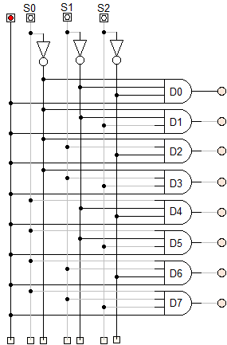

**OBSERVATION:**

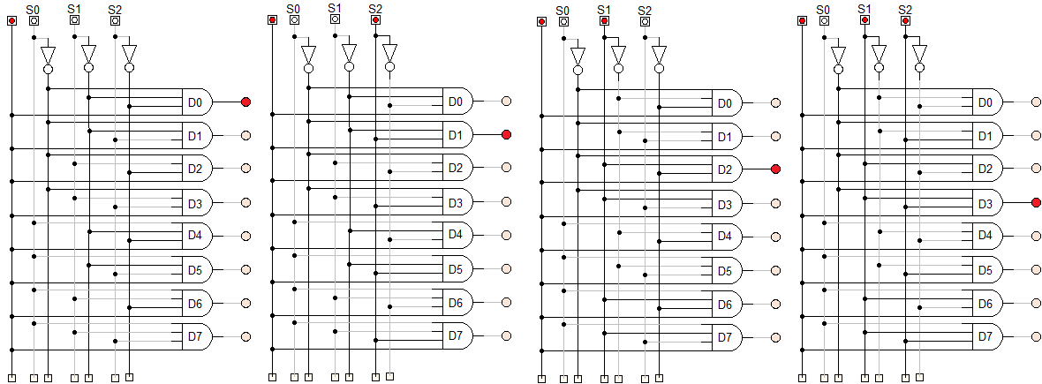

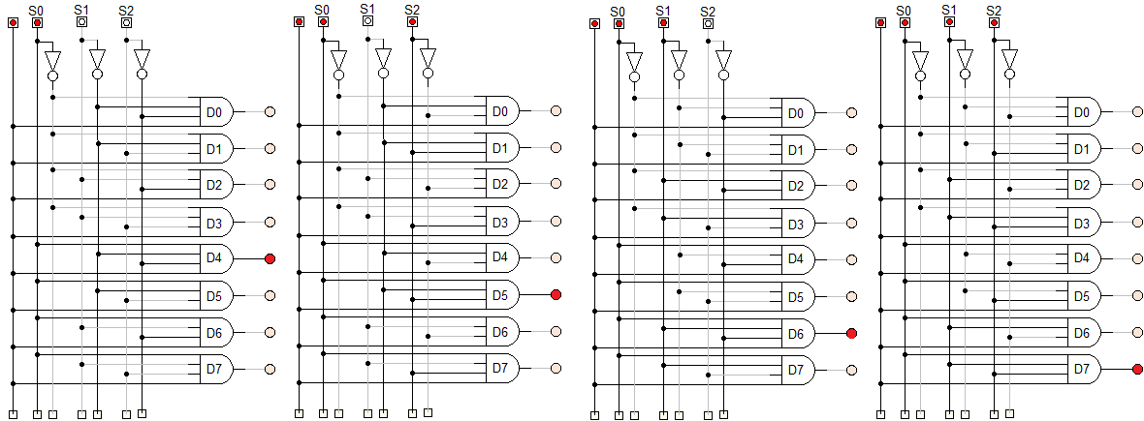

**OBSERVATION TABLE:**

|  |  |  |  |  |  |  |  |  |  |  |
| --- | --- | --- | --- | --- | --- | --- | --- | --- | --- | --- |
| **Switch** | | | **Outputs** | | | | | | | |
| **S0** | **S1** | **S2** | **D0** | **D1** | **D2** | **D3** | **D4** | **D5** | **D6** | **D7** |
| 0 | 0 | 0 | 1 | 0 | 0 | 0 | 0 | 0 | 0 | 0 |
| 0 | 0 | 1 | 0 | 1 | 0 | 0 | 0 | 0 | 0 | 0 |
| 0 | 1 | 0 | 0 | 0 | 1 | 0 | 0 | 0 | 0 | 0 |
| 0 | 1 | 1 | 0 | 0 | 0 | 1 | 0 | 0 | 0 | 0 |
| 1 | 0 | 0 | 0 | 0 | 0 | 0 | 1 | 0 | 0 | 0 |
| 1 | 0 | 1 | 0 | 0 | 0 | 0 | 0 | 1 | 0 | 0 |
| 1 | 1 | 0 | 0 | 0 | 0 | 0 | 0 | 0 | 1 | 0 |
| 1 | 1 | 1 | 0 | 0 | 0 | 0 | 0 | 0 | 0 | 1 |

**CONCLUSION:**

Hence, the operation of 1×8 DEMUX was verified.

**OBJECTIVE 10.3:**

**TO VERIFY THE OPERATION OF 1×16 DEMUX USING SMALLER BLOCKS**

**THEORY:**

The Block diagram is given below:

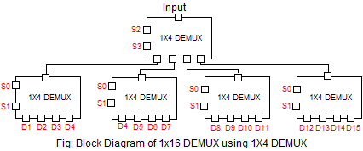

**TRUTH TABLE:**

|  |  |  |  |  |  |  |  |  |  |  |  |  |  |  |  |  |  |  |  |
| --- | --- | --- | --- | --- | --- | --- | --- | --- | --- | --- | --- | --- | --- | --- | --- | --- | --- | --- | --- |
| **Switch** | | | | **Outputs** | | | | | | | | | | | | | | | |
| **S0** | **S1** | **S2** | **S3** | **D0** | **D1** | **D2** | **D3** | **D4** | **D5** | **D6** | **D7** | **D8** | **D9** | **D10** | **D11** | **D12** | **D13** | **D14** | **D15** |
| 0 | 0 | 0 | 0 | 1 | 0 | 0 | 0 | 0 | 0 | 0 | 0 | 0 | 0 | 0 | 0 | 0 | 0 | 0 | 0 |
| 0 | 0 | 0 | 1 | 0 | 1 | 0 | 0 | 0 | 0 | 0 | 0 | 0 | 0 | 0 | 0 | 0 | 0 | 0 | 0 |
| 0 | 0 | 1 | 0 | 0 | 0 | 1 | 0 | 0 | 0 | 0 | 0 | 0 | 0 | 0 | 0 | 0 | 0 | 0 | 0 |
| 0 | 0 | 1 | 1 | 0 | 0 | 0 | 1 | 0 | 0 | 0 | 0 | 0 | 0 | 0 | 0 | 0 | 0 | 0 | 0 |
| 0 | 1 | 0 | 0 | 0 | 0 | 0 | 0 | 1 | 0 | 0 | 0 | 0 | 0 | 0 | 0 | 0 | 0 | 0 | 0 |
| 0 | 1 | 0 | 1 | 0 | 0 | 0 | 0 | 0 | 1 | 0 | 0 | 0 | 0 | 0 | 0 | 0 | 0 | 0 | 0 |
| 0 | 1 | 1 | 0 | 0 | 0 | 0 | 0 | 0 | 0 | 1 | 0 | 0 | 0 | 0 | 0 | 0 | 0 | 0 | 0 |
| 0 | 1 | 1 | 1 | 0 | 0 | 0 | 0 | 0 | 0 | 0 | 1 | 0 | 0 | 0 | 0 | 0 | 0 | 0 | 0 |
| 1 | 0 | 0 | 0 | 0 | 0 | 0 | 0 | 0 | 0 | 0 | 0 | 1 | 0 | 0 | 0 | 0 | 0 | 0 | 0 |
| 1 | 0 | 0 | 1 | 0 | 0 | 0 | 0 | 0 | 0 | 0 | 0 | 0 | 1 | 0 | 0 | 0 | 0 | 0 | 0 |
| 1 | 0 | 1 | 0 | 0 | 0 | 0 | 0 | 0 | 0 | 0 | 0 | 0 | 0 | 1 | 0 | 0 | 0 | 0 | 0 |
| 1 | 0 | 1 | 1 | 0 | 0 | 0 | 0 | 0 | 0 | 0 | 0 | 0 | 0 | 0 | 1 | 0 | 0 | 0 | 0 |
| 1 | 1 | 0 | 0 | 0 | 0 | 0 | 0 | 0 | 0 | 0 | 0 | 0 | 0 | 0 | 0 | 1 | 0 | 0 | 0 |
| 1 | 1 | 0 | 1 | 0 | 0 | 0 | 0 | 0 | 0 | 0 | 0 | 0 | 0 | 0 | 0 | 0 | 1 | 0 | 0 |
| 1 | 1 | 1 | 0 | 0 | 0 | 0 | 0 | 0 | 0 | 0 | 0 | 0 | 0 | 0 | 0 | 0 | 0 | 1 | 0 |
| 1 | 1 | 1 | 1 | 0 | 0 | 0 | 0 | 0 | 0 | 0 | 0 | 0 | 0 | 0 | 0 | 0 | 0 | 0 | 1 |

**CIRCUIT DIAGRAM:**

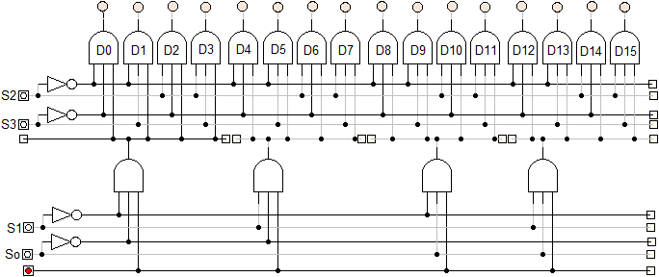

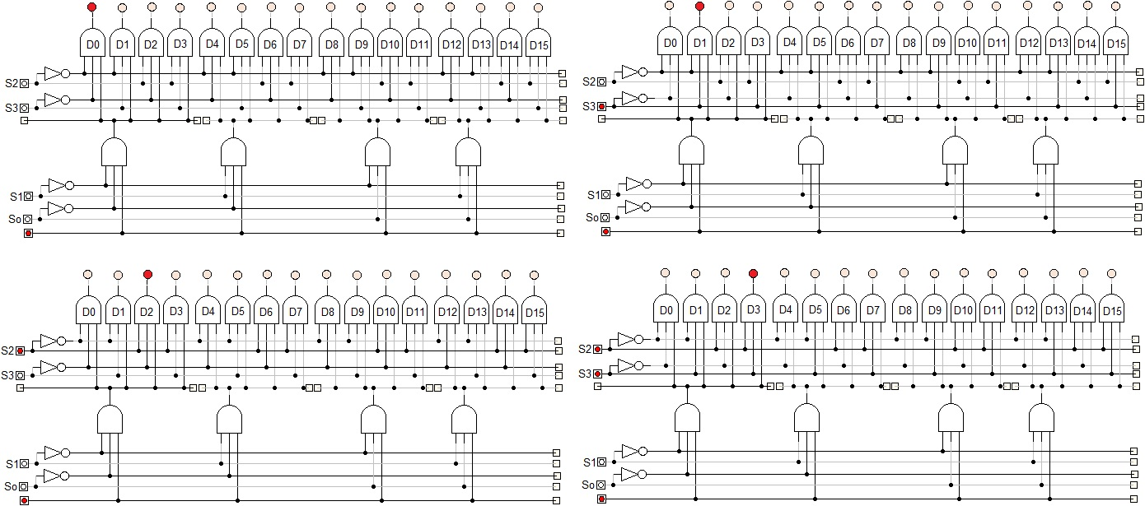**OBSERVATION:**

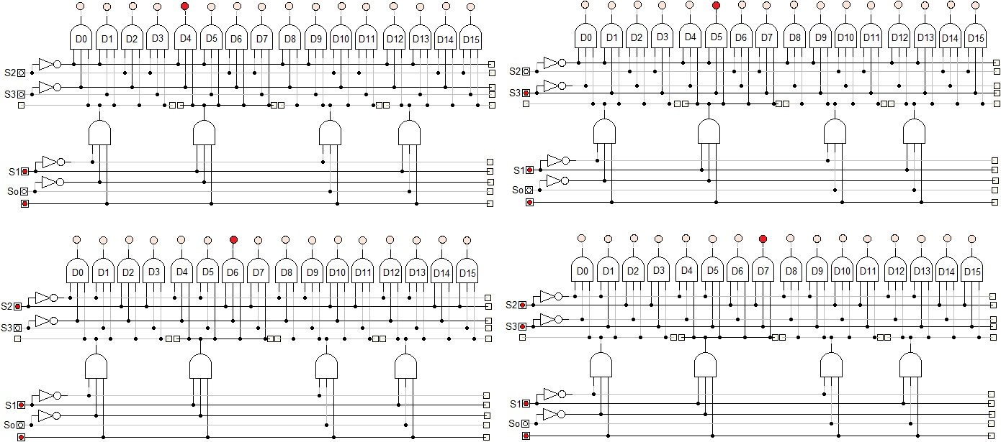

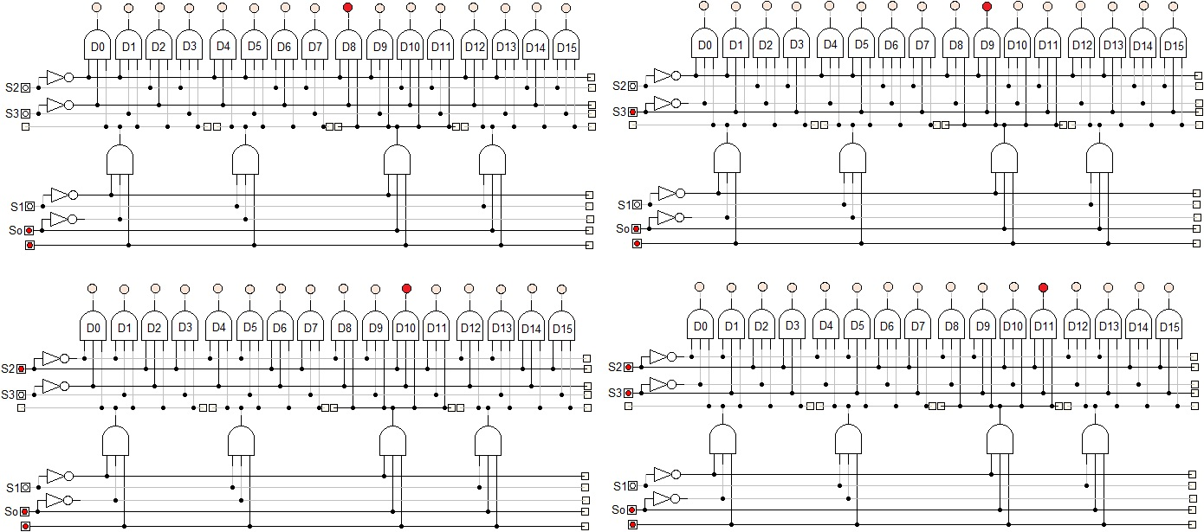

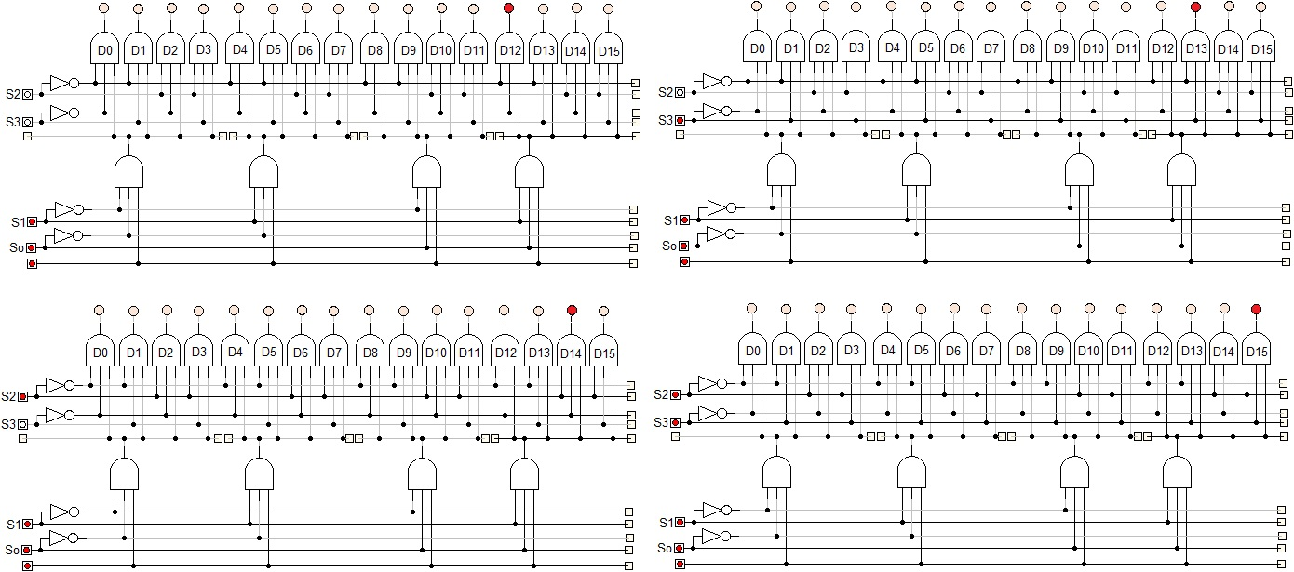

**OBSERVATION TABLE:**

|  |  |  |  |  |  |  |  |  |  |  |  |  |  |  |  |  |  |  |  |
| --- | --- | --- | --- | --- | --- | --- | --- | --- | --- | --- | --- | --- | --- | --- | --- | --- | --- | --- | --- |
| **Switch** | | | | **Outputs** | | | | | | | | | | | | | | | |
| **S0** | **S1** | **S2** | **S3** | **D0** | **D1** | **D2** | **D3** | **D4** | **D5** | **D6** | **D7** | **D8** | **D9** | **D10** | **D11** | **D12** | **D13** | **D14** | **D15** |
| 0 | 0 | 0 | 0 | 1 | 0 | 0 | 0 | 0 | 0 | 0 | 0 | 0 | 0 | 0 | 0 | 0 | 0 | 0 | 0 |
| 0 | 0 | 0 | 1 | 0 | 1 | 0 | 0 | 0 | 0 | 0 | 0 | 0 | 0 | 0 | 0 | 0 | 0 | 0 | 0 |
| 0 | 0 | 1 | 0 | 0 | 0 | 1 | 0 | 0 | 0 | 0 | 0 | 0 | 0 | 0 | 0 | 0 | 0 | 0 | 0 |
| 0 | 0 | 1 | 1 | 0 | 0 | 0 | 1 | 0 | 0 | 0 | 0 | 0 | 0 | 0 | 0 | 0 | 0 | 0 | 0 |
| 0 | 1 | 0 | 0 | 0 | 0 | 0 | 0 | 1 | 0 | 0 | 0 | 0 | 0 | 0 | 0 | 0 | 0 | 0 | 0 |
| 0 | 1 | 0 | 1 | 0 | 0 | 0 | 0 | 0 | 1 | 0 | 0 | 0 | 0 | 0 | 0 | 0 | 0 | 0 | 0 |
| 0 | 1 | 1 | 0 | 0 | 0 | 0 | 0 | 0 | 0 | 1 | 0 | 0 | 0 | 0 | 0 | 0 | 0 | 0 | 0 |
| 0 | 1 | 1 | 1 | 0 | 0 | 0 | 0 | 0 | 0 | 0 | 1 | 0 | 0 | 0 | 0 | 0 | 0 | 0 | 0 |
| 1 | 0 | 0 | 0 | 0 | 0 | 0 | 0 | 0 | 0 | 0 | 0 | 1 | 0 | 0 | 0 | 0 | 0 | 0 | 0 |
| 1 | 0 | 0 | 1 | 0 | 0 | 0 | 0 | 0 | 0 | 0 | 0 | 0 | 1 | 0 | 0 | 0 | 0 | 0 | 0 |
| 1 | 0 | 1 | 0 | 0 | 0 | 0 | 0 | 0 | 0 | 0 | 0 | 0 | 0 | 1 | 0 | 0 | 0 | 0 | 0 |
| 1 | 0 | 1 | 1 | 0 | 0 | 0 | 0 | 0 | 0 | 0 | 0 | 0 | 0 | 0 | 1 | 0 | 0 | 0 | 0 |
| 1 | 1 | 0 | 0 | 0 | 0 | 0 | 0 | 0 | 0 | 0 | 0 | 0 | 0 | 0 | 0 | 1 | 0 | 0 | 0 |
| 1 | 1 | 0 | 1 | 0 | 0 | 0 | 0 | 0 | 0 | 0 | 0 | 0 | 0 | 0 | 0 | 0 | 1 | 0 | 0 |
| 1 | 1 | 1 | 0 | 0 | 0 | 0 | 0 | 0 | 0 | 0 | 0 | 0 | 0 | 0 | 0 | 0 | 0 | 1 | 0 |
| 1 | 1 | 1 | 1 | 0 | 0 | 0 | 0 | 0 | 0 | 0 | 0 | 0 | 0 | 0 | 0 | 0 | 0 | 0 | 1 |

**CONCLUSION:**

Hence, the operation of 1×16 DEMUX was verified.